| Experiment No.1 |
| --- |
| Program to perform arithmetic operations by accepting values from users |
| Date of Performance: |
| Date of Submission: |

**Experiment No. 1**

**Title**: Program to perform arithmetic operations by accepting values from users

**Aim**: To write a program to perform arithmetic operations by accepting values from users

**Objective:** To introduce basic concepts in Python

**Theory**:

## **What is Python?**

Python is a popular programming language. It was created by Guido van Rossum, and released in 1991.

It is used for:

* web development (server-side),
* software development,
* mathematics,
* system scripting.

### What can Python do?

* Python can be used on a server to create web applications.
* Python can be used alongside software to create workflows.
* Python can connect to database systems. It can also read and modify files.
* Python can be used to handle big data and perform complex mathematics.
* Python can be used for rapid prototyping, or for production-ready software development.

### Why Python?

* Python works on different platforms (Windows, Mac, Linux, Raspberry Pi, etc).
* Python has a simple syntax similar to the English language.
* Python has syntax that allows developers to write programs with fewer lines than some other programming languages.
* Python runs on an interpreter system, meaning that code can be executed as soon as it is written. This means that prototyping can be very quick.
* Python can be treated in a procedural way, an object-oriented way or a functional way.

### Good to know

* The most recent major version of Python is Python 3, which we shall be using in this tutorial. However, Python 2, although not being updated with anything other than security updates, is still quite popular.
* In this tutorial Python will be written in a text editor. It is possible to write Python in an Integrated Development Environment, such as Thonny, Pycharm, Netbeans or Eclipse which are particularly useful when managing larger collections of Python files.

### Python Syntax compared to other programming languages

* Python was designed for readability, and has some similarities to the English language with influence from mathematics.
* Python uses new lines to complete a command, as opposed to other programming languages which often use semicolons or parentheses.
* Python relies on indentation, using whitespace, to define scope; such as the scope of loops, functions and classes. Other programming languages often use curly-brackets for this purpose.

**Arithmetic operators** are used to perform mathematical operations like addition, subtraction, multiplication and division.

There are 7 arithmetic operators in Python :

1. Addition
2. Subtraction
3. Multiplication
4. Division
5. Modulus
6. Exponentiation
7. Floor division

**Code**:

a=int(input("Enter the Number: "))

b=int(input("Enter the Number: "))

print("Addition is: ",(a+b))

a=int(input("Enter the Number: "))

b=int(input("Enter the Number: "))

print("Subtraction is: ",(a-b))

a=int(input("Enter the Number: "))

b=int(input("Enter the Number: "))

print("Multiplication is: ",(a*b))

a=int(input("Enter the Number: "))

b=int(input("Enter the Number: "))

print("division is: ",(a/b))

a=int(input("Enter the Number: "))

b=int(input("Enter the Number: "))

print("Exponent is: ",(a**b))

a=int(input("Enter the Number: "))

b=int(input("Enter the Number: "))

print("Modulo is: ",(a % b))

a=int(input("Enter the Number: "))

b=int(input("Enter the Number: "))

print("Floor Division is: ",(a//b))

**Output**:

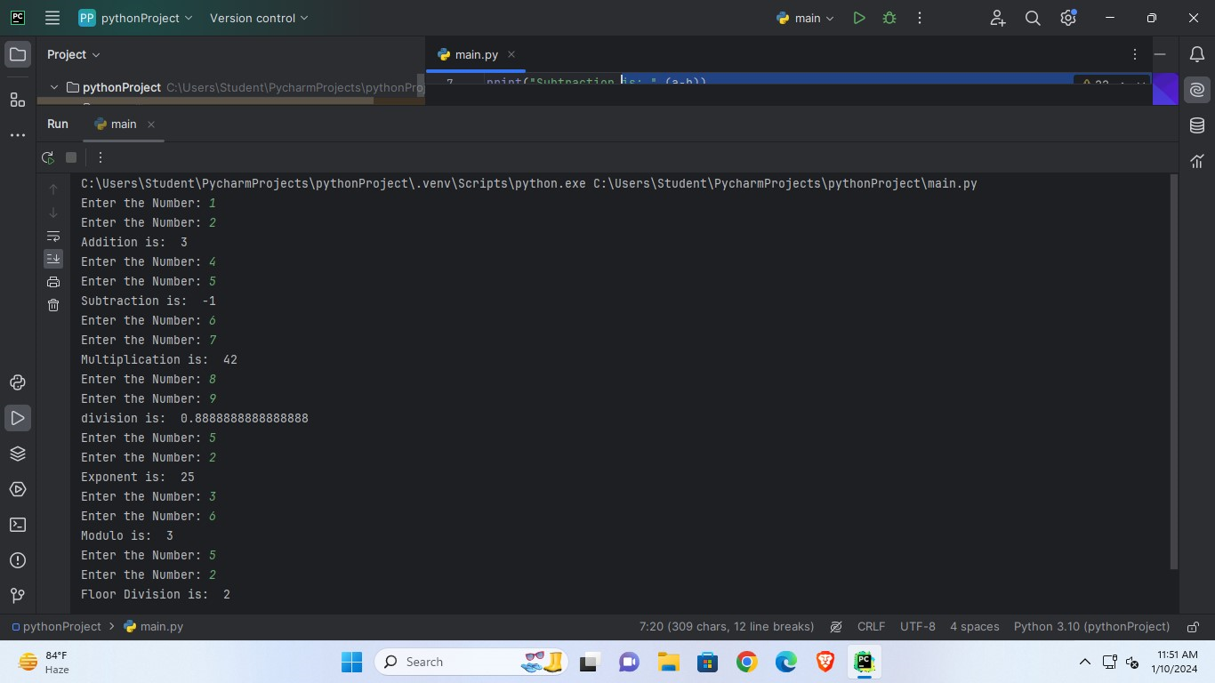

**Conclusion:** In this code by using the arithmetic concept of addition, subtraction, multiplication, division, Exponential, modulo, floor division, we performed all this respective operations. This is how the arithmetic operations are carried out in python programming.